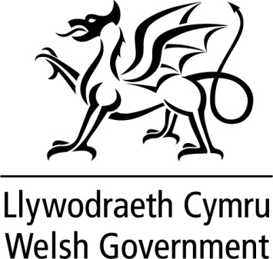

WRITTEN STATEMENT

BY

THE WELSH GOVERNMENT

TITLE | Additional support for businesses in dealing with Covid-19
DATE | 19 March 2020
BY | Rebecca Evans AM, Minister for Finance and Trefnydd

Following our announcement of a £200 million package of support for businesses on 17 March, the Welsh Government is today announcing that we will be providing almost £1.4 billion of support for businesses during this difficult period.

All retail, leisure and hospitality businesses will receive 100% non-domestic rates relief in 2020-21. This enhanced retail, leisure and hospitality relief scheme, in combination with our existing Small Business Rates Relief scheme, will ensure that over 70,000 businesses in Wales will pay no rates at all in 2020-21.

In addition to this enhanced retail, leisure and hospitality relief scheme, £850m will be available for a new grant scheme for businesses.

All businesses currently eligible for Small Business Rates Relief – those with a rateable value up to £12,000 – will receive a grant of £10,000. Retail, leisure and hospitality businesses with a rateable value between £12,001 and £51,000 will receive a grant of £25,000. This support will operate in addition to our existing £230 million package of rates reliefs.

We are also establishing a hardship fund to provide targeted support for certain other businesses.

This significant package makes full use of the consequential funding for Wales resulting from the Chancellor’s Budget on 11 March and his announcement on 17 March.

Through this package, we will be supporting businesses across Wales in responding to the immediate effects of the Coronavirus. However, we have reiterated our call on the UK Government to establish a series of much more fundamental measures to enable businesses to survive and to support employees until such time as the economy can resuming something like normal trading.

